Lab 2 – Dart Essentials Practice Lab
1. Objective
This lab helps students build a strong foundation in Dart by practicing core language features including program structure, data types, variables, collections, control flow, functions, OOP basics, null safety, async/await, and streams.
All exercises can run directly on DartPad, Android Studio, or VS Code.
2. Requirements
Complete five exercises covering the fundamental concepts of Dart:
1. Basic Syntax & Data Types – practice printing output and using core types.
2. Collections & Operators – manipulate lists, sets, and maps using Dart operators.
3. Control Flow & Functions – implement logic using if/else, switch, loops, and functions.
4. Intro OOP – create classes, constructors, inheritance, and method overriding.
5. Async & Null Safety – work with async/await, Futures, and null-safety operators.
Each task must:
· Compile and run successfully.
· Print results to the console.
· Contain comments explaining the code.

3. Guided Steps
Exercise 1 – Basic Syntax & Data Types
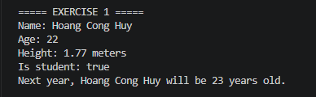
Exercise 2 – Collections & Operators
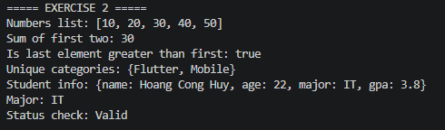
Exercise 3 – Control Flow & Functions
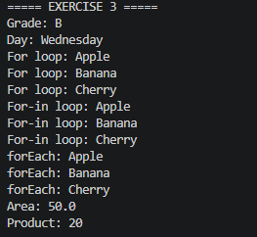
Exercise 4 – Intro to OOP
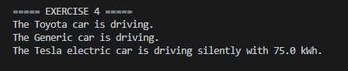
Exercise 5 – Async, Future, Null Safety & Streams
